ORNAO

Operating Policies
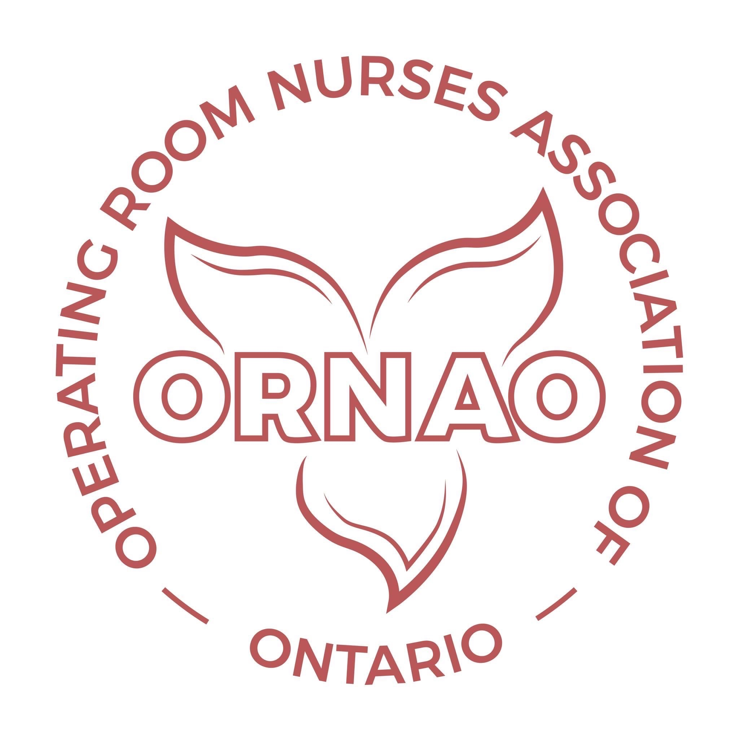
Date of Last Review and Revision: December 5, 2023
Next Review and Revision: By December 5, 2025
Table of Contents
Section 1 3
Philosophy Statement 3
Mission/Vision/Values Statement 4
Mission Statement 4
Vision Statement 4
Values Statement 4
Goals and Objectives 5
Section 2 6
ORNAO Organizational Structure 6
Current Executive & Regional Representatives (Board Members) & Past Presidents 7
Section 3 8
ORNAO Board Role Descriptions 8
ORNAO President 8
ORNAO President-Elect 10
ORNAO Treasurer 11
ORNAO Secretary 13
Past President 14
ORNAO Regional Representatives 14
Section 4 17
ORNAO Committees 17
Ad Hoc Committees 17
Standing Committees 17
Section 5 20
Archives Policy Statement 20
Section 6 21
Financial Policies 21
Funding for ORNAO Board Members Attending a Conference 21
ORNAO Executive Funding 22
ORNAO Committee Member Funding 23
Regional Membership Funding for Education 23
Expense Claim Form 24
Section 7 25
Webinar Policy 25
To Be developed 25
Section 8 26
Guideline for the Use of the ORNAO Logo 26
Privacy Policy — Protection of Personal Information 27
Section 9 31
Conflict of Interest Policy 31
APPENDIX 1: Nomination Forms 32
Nomination Forms 32

Section 1
Philosophy Statement | Section 1 – 1.1
 | Revised: May 23, 2023

The Operating Room Nurses Association of Ontario is an organization of professional nurses dedicated to the promotion of excellence in perioperative nursing in the immediate preoperative, intraoperative, and the immediate postoperative periods of the patient’s surgical experience.
The Association serves as a spokesperson for perioperative nurses on issues affecting nurses, nursing practice, patient care and societal needs.
The Association believes that:
- Perioperative nursing is a dynamic process guided by theoretical knowledge, ethical principles, research, caring practice and specialized clinical skills. Perioperative nurses respond to complex and changing needs of persons during a crucial period of the surgical experience. The scope of practice is continually evolving as nurses respond to societal and technological changes.
- Standards of nursing practice and collegial and interdisciplinary collaboration enhance perioperative nursing practice.
- Persons are unique individuals whose needs are potentially compromised and changed during the surgical experience. Persons have a right to high quality health care that allows informed and responsible decision-making.
- Health encompasses the whole being and is influenced by one’s environment. Using a wellness approach, individuals and communities must be proactive and responsible for achieving optimal health.
- Education is an ongoing, lifelong process and that nurses assume responsibility for their learning. The Association is committed to enabling nurses to meet this responsibility.
- The introduction to perioperative nursing should be a component of the generic curriculum, but that the acquisition of knowledge and clinical skills for professional and clinical perioperative nursing practice is a continuous process starting at the post generic level.
- Its activities should strive to meet the needs of its Members and the Public.

Mission/Vision/Values Statement | Section 1 – 1.2
 | Revised: May 23, 2023
Mission Statement
The Operating Room Nurses Association of Ontario is an organization of Peri-operative Nurses dedicated to the promotion and advancement of excellence in perioperative client care through a unified approach to continuing education, research, ORNAC standards implmentation and advocacy.
Vision Statement
Enhance and advance perioperative nursing practice in Ontario.
Values Statement
These values reflect the basic beliefs that are most important to the Operating Room Nurses Association of Ontario:
Knowledge: We recognize and are committed to education and research as essential components guiding our practice.
Collaboration: We will collaborate with nurses within our specialty organizations/ agencies and other disciplines that impact our practice.
Respect: We will recognize worth, quality, diversity and importance of each other and the clients we “care” for.
Professionalism: We will work together to promote and advance our specialty.
Continuous Quality: We will strive to achieve excellence in perioperative practice and activities influencing our Association.

Goals and Objectives | Section 1 – 1.3
 | Revised: May 23, 2023

Goals will reflect the Mission, Vision and Values of the Operating Room Nurses Association of Ontario.
GOAL 1: Build a sustainable provincial association to advance perioperative practice.
Objectives: 1.1 Develop a value proposition and Member benefits to retain and attract new Members
1.2 Track/trend regional and provincial membership numbers quarterly
1.3 Recognize regions where issues of decreasing membership numbers arise
1.4 Identify strategies to increase membership numbers in regions as indicated in 1.3
GOAL 2: To represent all perioperative nurses, who are practicing in Ontario at the direct care, education, research, and administrative levels.
Objectives: 2.1 Identify opportunities to advocate for perioperative nursing practice
2.2 Determine research initiatives to advance perioperative practice
2.3 Unify the voice of Ontario perioperative nurses in order to drive change
2.4 Provide educational opportunities to meet the needs of ORNAO Members within Ontario
GOAL 3: To support Ontario perioperative nurses in their regions by assisting them to attain and retain excellence in perioperative nursing practice in Ontario through participation in Quality Assurance initiatives.
Objectives: 3.1 Provide opportunities for self-directed learning through ORNAO webinars and educational intiatives provincially and nationally.
3.2 Encourage members to achieve the Canadian Nurses Association Certification in Perioperative Nursing, CPN(C).
3.3 Manage the ORNAO regional funds to support perioperative nurses education in our specialty.
GOAL 4: To act as a resource for all perioperative nurses in Ontario.
Objectives: 4.1 Provide access to information on perioperative practice in Ontario through the ORNAO website.
4.2 Facilitate best practices through networking and collaboration through quarterly member Zoom meetings and at sponsored events such as biennial conferences.
Section 2
ORNAO Organizational Structure | Section 2 – 2.1
 | Revised May 23, 2023
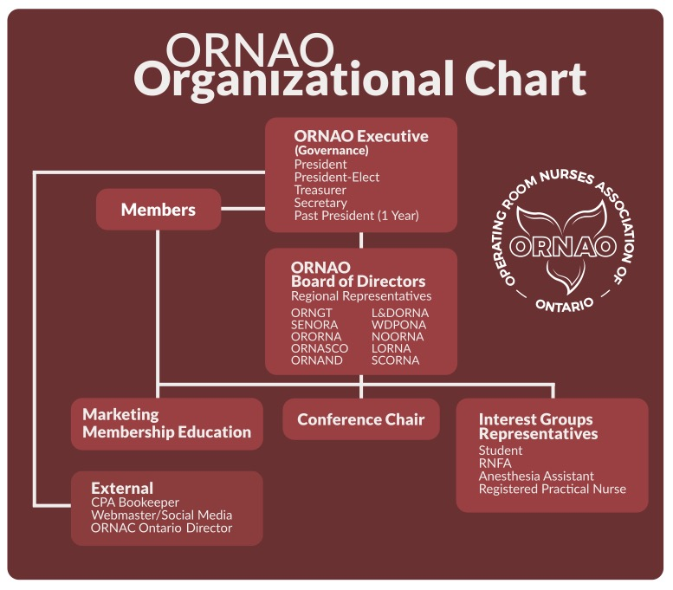

Current Executive & Regional Representatives (Board Members) & Past Presidents | Section 2 – 2.1
 | revised: may 23, 2023
ORNAO Executive
See ORNAO website, http://www.ornao.org/, for current Executive
ORNAO Regional representatives (Board)
See ORNAO website, https://www.ornao.org/ornao-executive for current Board
ORNAO Past Presidents
See ORNAO website, https://www.ornao.org/ornao-executive for Past President

Section 3
ORNAO Board Role Descriptions | Section 3 – 3.1, 3.2 ,3.3, 3.4, 3.5, 3.6, 3.7
 | revised: maRch 8, 2023
The ORNAO Board are responsible for participating in the recruitment, nomination and appointments of new Board Executive and Regional Representatives with the right mix of skills, knowledge and experience. Most boards assess their performance on an annual basis to identify gaps and form a strategic plan. They will also address equity, diversity and inclusion in their board recruitment and selection process.
ORNAO President
- The President shall be an Executive Member of the Board .
- The President shall have served as President-Elect before becoming President if possible.
Accountability
As an Executive Member of ORNAO, the President serves and is accountable to the ORNAO Board and ORNAO Members.
Authority
The President is entitled to make motions and has one vote on matters before ORNAO.
Time Commitment
Five hours per month (Board meetings, developing the agenda for Board meetings and reviewing Executive and Board meeting minutes, attending special events).
Term of Office
Two year term and then is appointed to a one year term as the Immediate Past President.
Specific Responsibilities
Meetings and Elections
- Develop the agenda in conjunction with the ORNAO Secretary, call and preside at all meetings of the ORNAO (e.g., Board Meetings, Conference, Annual General Meeting, Strategic Planning) as set forth in the by-laws.
- During a vote of the Board, in the case of a tie, the President as Chair of the meeting in addition to an original vote shall have a second or casting vote.
- Notify the President-Elect if unable to preside over any regular and/or special meetings of the Board or Membership.
- Appoint a Nominating Committee Chair and receive nominations from the Chair. Work with the Nominating Committee Chair and Executive to ensure that all holders of Board positions nearing the completion of their term are announced to the membership in a timely manner so that these positions can be filled by the Annual General Meeting.
- If the Nominating Committee Chair cannot be present for an election, appoint three scrutineers and designate one to count ballots during voting for election of officers.
Operations
- Ensure efficient and effective operations of ORNAO and that mandated and legislated functions of the Association are fulfilled.
- Hold Executive meetings at least once per month to monitor the status of the Operational Plan and projects and address issues.
- Collaborate with the Executive to develop the annual Operational Plan based upon the ORNAO Strategic Plan for approval by the Board.
- Review the status of the Operational Plan at each Board meeting and during the Annual General Meeting to inform members.
- Approve and sign, or delegate to another officer with signing authority, to approve and sign contracts and Memoranda of Understanding.
- Together with the Board , appoint Chairs of committees and task forces.
- Work with committees and task force Chairs to guide the activities of core programs, committees and task forces.
- Mentor the President-Elect for succession planning.
Communications
- Develop the annual Communication Plan with the Board in consultation with the Board.
- Report to the Board on accomplishments, activities, trends, and organizational issues of interest and concern on a regular basis.
- Prepare a written report and submit to the Board as an annual report to the Members prior to the Annual General Meeting.
- Work with consultants to communicate with Members electronically as necessary.
- Review and approve e-blasts.
- Ensure communication, (ORNAO e-blasts) to members regarding AGM and bylaw changes within the appropriate timeframes.
- Support collaborative partnerships with aligned organizations as determined in the Strategic Plan
- Communicate with Presidents of aligned organizations such as ORNAC as needed.
- Represent the ORNAO at conferences/events or designate representatives as outlined in the Strategic Plan based on budget approval by the Board.
- Receive and deal with electronic and hard copy ORNAO correspondence sending copies to appropriate board members.
Qualifications
- Must be a Member of ORNAO/ORNAC
- A commitment to, and a clear understanding of the Mission of the organization.
- Knowledge of meeting procedures, governance policies and by-laws of the Association.
ORNAO President-Elect
- The President-Elect shall be an Executive member of the ORNAO Board .
- At the conclusion of their term, the President-Elect is appointed into the ORNAO President’s position.
- The President-Elect supports the President in fulfilling the goals and objectives of the Association. The President-Elect provides continuity to established programs and the plans for future programs for which they will be responsible for during their presidency.
- The President-Elect assumes all duties and responsibilities of the President in the event the President is absent or unable to perform the President’s duties.
- By being fully informed of the activities in all areas of ORNAO, the President-Elect will be prepared to assist the President in any way and to assume the responsibilities of the office of President should the need arise.
Accountability
As an Executive Board Member of ORNAO, the President-Elect serves and is accountable to the ORNAO Board.
Authority
The President-Elect is entitled to make motions and has one vote on matters before ORNAO.
Time Commitment
Five hours per month (board meetings, supporting the agenda development for Board meetings and Executive meeting minutes, attending special events).
Term of Office
Two year term as President-Elect and then is appointed to a two year term as President and then is appointed to a one year term as Immediate Past-President.
Specific Responsibilities
- Attend all meetings of ORNAO (e.g. Board, represent ORNAO at conferences, Annual General Meeting, Strategic Planning, other meetings as assigned by the President).
- Serve as the ORNAO Privacy Officer ensuring that the Association abides by the privacy laws.
- Attend meetings with the President to monitor the status of the Operational Plan and projects and address issues.
- Act as Chair of the Nominating Committee and conduct elections when required.
- Support committees when requested by the Board.
- Perform other duties as assigned by the President and/ or the Board.
Qualifications
- Must be a Member of ORNAO/ORNAC
- A commitment to, and a clear understanding of the Mission of the organization.
- Knowledge of meeting procedures, governance policies and by-laws of the Association.
ORNAO Treasurer
- The ORNAO Treasurer shall be an Executive Member of the ORNAO Board.
- The Treasurer manages and monitors the financial condition of ORNAO and keeps the ORNAO Board updated on all financial matters in order for them make better decisions.
Accountability
The Treasurer provides oversight over all aspects of financial management, working closely with other members of the ORNAO Board to safeguard the Association’s finances and is accountable to the Board and Members of ORNAO.
Authority
The Treasurer is entitled to make motions and has one vote on matters before the ORNAO Board.
Time Commitment
Four hours month (board meetings and executive board meetings), presents the financial results at ORNAO Board Meetings, develops and obtains approval of the annual budget, oversight of financial process, ensures that financial documentation is in order.
Term of Office
Two year term with a two year renewal option but must be nominated and elected for the second term.
Specific Responsibilities
General Financial Oversight
- Oversee and present budgets, accounts and financial statements to the Board.
- Liaise with the ORNAO bookkeeper about financial matters.
- Ensure that appropriate financial systems and controls are in place.
- Ensure that accurate records are kept of regional Membership money
- Assign the regional Member’s funds and allocate accordingly in the financial records.
- Ensure that record-keeping and accounts meet the conditions of funders or statutory bodies.
- Pays invoices in a timely manner.
- Ensure compliance with relevant legislation.
Funding, Fundraising and Sales
- Advise on ORNAO’s fundraising strategy.
- Ensure use of funds complies with conditions set by funding bodies.
- Ensure fundraising and sales comply with relevant legislation and is bound by effective financial systems and controls.
- Ensure effective monitoring and reporting.
Financial Planning and Budgeting
- Prepare and present budgets to the ORNAO Board of Directors and Members (during AGM) for new or ongoing work.
- Advise on financial implications of strategic and operational plans.
- Oversees the ORNAO conference budget.
- Present revised financial forecasts based on actual spend.
Financial Reporting
- Present monthly reports on ORNAO’s financial position.
- Present the ORNAO year-end financials at the ORNAO AGM.
- Report on the Regional Member’s funds during the AGM.
- Advise on ORNAO reserves.
Banking, Book-Keeping and Record-Keeping
- Ensure everyone handling money keeps proper records and documentation.
- Ensure proper records are complete.
- Ensure required insurances are in place.
- Receive submitted expense claims and process.
- Ensure financial policies are in place.
Qualifications
- Must be a Member of ORNAC/ORNAO.
- A commitment to, and a clear understanding of the Mission of the organization.
- Knowledge of meeting procedures, governance policies and by-laws of the Association.
- Experience reading balance sheets, profit and loss statements, and relevant financial documents.
- Understanding of rules and regulations of financial oversight in a not -for- profit association.
- Sufficient time to devote to their primary duties .
- Strong organizational and communication skills.
Development & Evaluation
The Treasurer shall regularly consult the ORNAO Board on their expectations of the Treasurer role and assess their strengths and areas for improved effectiveness.
ORNAO Secretary
- The ORNAO Secretary shall be an Executive Member of the Board.
- The Secretary operates as the custodian of ORNAO’s records. This duty involves ensuring the organizational records are maintained according to law and are available upon request by authorized board members or executive management. This includes updating the organization's bylaws and maintaining its articles of incorporation along with keeping accurate and up-to-date records of board minutes, financial reports and other important documents.
Accountability
As an Executive Board Member of ORNAO, the Secretary serves and is accountable to the ORNAO Board.
Authority
The Secretary is entitled to make motions and vote on matters before the ORNAO Board.
Time Commitment
Four hours per month (board meetings, assisting with the agenda for board meetings, taking Board meeting minutes and executive meeting minutes, attending special events).
Term of Office
Two year term and two year renewal option but must be nominated and elected for the second term.
Specific Responsibilities
Maintenance of all ORNAO Records
- Maintains accurate documentation that meets legal requirements.
- Assures that documents (bylaws, roster of board members) are accessible to Board Members via the ORNAO Board Member website.
- Ensures all documents are reviewed and updated as required on an annual basis and ensures all documents are safely stored and readily accessible for inspection by Board Members.
Agenda and Minutes of Meetings
- Assures that an agenda has been prepared by the Board President and that the agenda and background information are distributed at least one week in advance of the meeting.
- Prepares the official minutes of Board and Annual General meetings - recording motions, discussions, votes, and decisions.
- Provides the previous meeting’s written minutes to board members before the next meeting and records any changes or corrections.
- Schedules and notifies board members and membership of upcoming meetings as required.
Qualifications
- Must be a Member of ORNAC/ORNAO.
- A commitment to, and a clear understanding of the mission of the organization.
- Knowledge of meeting procedures, governance policies and by-laws of ORNAO.
- Sufficient time to devote to their primary duties .
- Strong organizational and communication skills.
Development & Evaluation
The Secretary shall regularly consult the Board on their expectations of the Secretary role and assess their strengths and areas for improved effectiveness.
Past President
- The Past President shall be a non-voting Member of the ORNAO board representing and working on behalf of the entire Membership.
- The Past President shall serve after completing the President’s term.
Accountability
As a non-voting Member of the ORNAO Board, the Past President serves and is accountable to the ORNAO Board and ORNAO Members.
Authority
The Past President is entitled to act as an advisor to support the ORNAO Board but has no vote on matters before ORNAO.
Time Commitment
2 hours per month (Board meetings when invited by the President, reviewing Executive and Board meeting minutes, attending special events)
Term of Office
One year term and then is off of the Board.
Specific Responsibilities
- Serve as an advisor to the Executive and Board.
- During their one year term, review and submit recommended revisions of the the Operational Policies and Bylaws and send to the Board for consideration , feedback and voting in preparation for the Annual General Meeting.
ORNAO Regional Representatives
The ORNAO Regional Representatives represent one of the following ORNAO Regions and have the right to one vote as a Board Member:
- LORNA (LAKEHEAD OPERATING ROOM NURSES ASSOCIATION)
- L&DORNA (LONDON & DISTRICT OPERATING ROOM)
- NOORNA (NORTHERN ONTARIO periOPERATIVE REGISTERED NURSES ASSOCIATION)
- ORNAHD (OPERATING ROOM NURSES ASSOCIATION OF HAMILTON & DISTRICT)
- ORNASCO (OPERATING ROOM NURSES ASSOCIATION OF SOUTH CENTRAL ONTARIO)
- ORNGT (OPERATING ROOM NURSES OF GREATER TORONTO)
- ORORNA (OTTAWA REGIONAL periOPERATIVE REGISTERED NURSES ASSOCIATION)
- SCORNA (SUNSET COUNTRY OPERATING ROOM NURSES ASSOCIATION)
- SENORA (SOUTH EASTERN NURSES OPERATING ROOM ASSOCIATION)
- WDPONA (WINDSOR & DISTRICT PERIOPERATIVE NURSES ASSOCIATION)
Accountability
As a Regional Representative and key Volunteer of the association, the Regional Representative provides oversight over the business operations working closely with other members of the ORNAO to support the sustainability of ORNAO.
Authority
The Regional Representative is entitled to make motions and has one vote on matters before ORNAO.
Time Commitment
Three hours month (Board meetings , webinars, dissemination of information to the region as requested by the President)
Term of Office
Two year term with a two year renewal option but must be nominated and elected for the second term.
Responsibilities
Communication Conduit Between ORNAO and the Region
Liaise with regional Membership to share information from ORNAO in order to keep members updated and attract and retain members. The Regional Representative will be provided with Zoom access in order to set up and hold meetings with their regional Members.
Organization Strategic Planning and Monitoring
Regional Representatives will be involved in reviewing and implementing the Mission and Purpose statements that articulates ORNAO’s goals and people served. Regional Representative must actively participate in an overall strategic planning process and monitoring of the plan’s goals. As part of this, they may also monitor the organizations’ programs and services to determine which are consistent with the ORNAO Mission and monitor their effectiveness.
Provide Financial Oversight for Their Regional Members
Regional Representatives need to provide oversight to the allocation of their Regional Member’s funds. The Regional Representatives will have access to the ORNAO Treasurer in order to discuss the money available to Members as per the ORNAO Policy that describes funds that go back to their region.
Opportunity to Serve on AD HOC Committees
Regional Representatives have the opportunity to serve on AD HOC Committees and offer to take on special assignments, as this is where the bulk of board work gets done. Boards can also create ad hoc committees or working groups to accomplish specific goals or tasks.
Active Participation at Board Meetings and Annual AGM
Regional Representatives are expected to attend Board meetings in order to contribute to the discussion and decision making process.
Qualifications
- Must be a Member of ORNAC/ORNAO
- A commitment to, and a clear understanding of the Mission of the organization
- Knowledge of meeting procedures, governance policies and by-laws of the Association
- Sufficient time to devote to their primary duties
- Strong communication and organizational skills
- Reside within their area of regional representation
Development & Evaluation
The Regional Representatives shall regularly consult the Board on their expectations of the Regional Representative role and assess their strengths and areas for improved effectiveness.
Section 4
ORNAO Committees | Section 4 – 4.1, 4.2, 4.2.1, 4.2.2
 | revised: may 23, 2023
Ad Hoc Committees
- Will be formed by the Board as necessary.
- Committee Chairs will be appointed by the Board.
- The Committee Chair will recruit up to 3 Committee members supported by the Board. The Committee may include Board Representatives or Members at large.
- Terms of Reference will be developed for each Ad Hoc Committee.
Standing Committees
Standing Committees of ORNAO are as follows:
- Conference Planning Committee
- Nominations Committee
  - The Chairpersons of a Standing Committee shall be appointed by the Board :
    - Conference Planning – Current Board or Executive Member
    - Nominations – President -Elect
  - Membership will be defined in the Terms of Reference for each committee, which will be maintained in the Operating Policy.
  - Members of Standing Committees need not necessarily be Board members, but they must meet the definition of a Perioperative Registered Nurse and must be a member of ORNAC/ORNAO.
Conference Planning Committee (Standing)
Role:
- To organize a provincial perioperative conference.
- To provide education opportunities to the ORNAO membership.
Responsibilities:
- Determine the conference date in conjunction with the Board.
- Start conference planning 24 months prior to the conference date.
- Develop an ORNAO Conference Master Plan and budget which is approved by the Board.
- Assign roles of the conference planning committee.
- Review and maintain the ORNAO Conference manual.
- Distribute requests for ORNAO Conference Planning Membership using the job description and Skills-set template.
- Regular reporting on the status of the Conference Plan and budget at the Board meetings.
- Review the ORNAO Conference Committee guidelines and assign duties to the conference planning members.
- Ensure the Master Plan and Committee Guidelines following each conference have been reviewed and revised.
- Arrange a wrap-up meeting with the Conference Planning Committee at the end of the conference.
- Secure vendors to support sponsorship of the conference.
- Manage the exhibit floor layout.
Conference Planning Committee Membership:
Chairperson: Appointed by the Board
Members: Treasurer: ORNAO Treasurer
Secretary: 1
Hospitality: 2 (of which one will be from host city or region)
Educational Program: 2
Marketing/Publicity: 1
IT support and Registration: professional company
Terms of Office:
Determined by Chairperson
Meetings:
Zoom Meeting Platform or as determined by the Chair
Responsible To:
ORNAO Executive and Board of Directors
Responsibilities of the Board at the Provincial Conference
- Since Executive and Board members travel and conference registration are covered by the conference budget if possible, the Board is expected to attend all special functions, such as All Exhibitors’ Night, Cocktail Hour, dinner and any other social events scheduled at conferences.
- It is important that the Executive and Board members show support of all functions. If there are a large number of functions then the Executive should be assigned events to attend.
- The Executive and Board members’ obligation is to be visible as much as possible, network with the delegates and show support to the Planning Committee.
- Executive and Board members must be seen in the exhibit areas and visit booths, particularly the smaller company booths.
- Must fulfill assigned duties as requested by the Conference Planning Committee.
- Must attend entire conference.
NOMINATIONS Committee
Purpose:
Conduct a fair and unbiased process in which Board Members are provided the opportunity to be nominated for and run for positions within ORNAO. If more than one candidate runs for a position, this committee will develop and implement a fair and transparent election process.
Responsibilities:
- Prepare a call for nominations which will be sent by E Blast in January to all Members of ORNAO with a closing date of March 15.
- AGM will be held within six (6 ) months of the fiscal year end.
- Assess that candidates nominated meet the eligibility criteria for the position.
- Create the election slate which is reviewed and approved by the Board. If more than one candidate - a date for an election and the election process is communicated.
- Present list of nominees to the Executive and Board.
Membership:
Chairperson: President-Elect or appointed Board Member
Members: 3 Members will be appointed by the Board
Terms of Office:
Two year term
Meetings:
Annually in conjunction with the Annnual General Meeting.
Responsible To:
ORNAO Executive and Board of Directors.
Section 5
Archives Policy Statement | Section 5
 | revised: may 23, 2023
The ORNAO Archives exists to:
- Collect and preserve archival materials which illustrate the growth and development of the Operating Room Nurses Association of Ontario, both before and after organization, or which pertain in whole or part to activities within the geographic boundaries of ORNAO.
- Arrange and describe these materials according to archival principles and make them accessible to the membership on a regular basis, unless access is restricted by legal requirements or written agreements with the donor.
- Provide adequate and appropriate conditions for the storage, protection and preservation of archival materials.
- Provide regular reference services to individuals, organizations, government, or other groups interested in the activities and holdings of the Archives.
- Provide educational and outreach programming whenever possible to increase awareness and appreciation of the ORNAO’s history and development.
Material acquired by ORNAO Archives shall become the permanent property of the Archives and therefore, the organization until such time as the Archivist deems it no longer relevant to the Archives, in which case the material may be deaccessioned. Deaccessioning will not take place without the written approval of the Archives Board and deaccessioning and disposition of material will be retained in Archives’ records.
The Archives retains the right to reproduce materials by mechanical, electronic or photographic means for security, conservation or research purposes.
The Archives will accept historical material of any medium including Textual Records, Photographs and other visual records, maps, plans,architectural records, and oral history recordings.
The Archives will accept books, printed material, artifacts and electronically stored material at the discretion of the archivist.
Section 6
Financial Policies | SECTION: 6
 | revised: July 15, 2023
Funding for ORNAO Board Members Attending a Conference
Please note that the Board has the right to change the financial policy based on the current financial status of ORNAO.
Registration Fees:
Conference registration fee (including the price of banquet ticket).for a Provincial Conference, will be covered by ORNAO when the Board Member has met criteria as follows:
- attendance at the entire conference
- fulfill assigned conference duties.
Transportation:
Reimbursement will be based on the most practical and cost effective means of transportation.
- Economy airfare
- Economy railway or bus fare
- Personal car at $0.50 per kilometer
- When members travel together in a car, only one person will be reimbursed
- Transportation to and from airport if greater than 50 km
- Taxis – Individuals are requested to use airport limousine or bus service to/from airports and hotels, or to share taxis where possible
- Receipts for taxis/Uber must be attached to expense claim
Hotel Accommodation:
Based on shared occupancy where possible.
Single room occupancy must be pre-approved by the ORNAO President and ORNAO Treasurer six ( 6 )weeks prior to arrival. The Board member requesting the single occupancy will be responsible for half of the room cost.
- Incidental room charges are the Board Member’s responsibility.
- Parking, rooms and taxes are covered by ORNAO.
Meals:
- Meals before departure are at the expense of the Board member, unless extenuating circumstances are encountered i.e. flight delay greater than four (4) hours or a flight cancellation.
- Alcohol charges will not be reimbursed.
- If ORNAO is oproviding a meal and the Board Member decides not to join the group, that member’s meal will not be reimbursed.
- Original receipts must accompany expense claims up to $70.00/day. Breakfast - $15.00; Lunch - $25.00; Dinner - $35.00
Expense Reimbursement Form:
- Complete the current Expense Reimbursement Claim Form and return with original receipts to ORNAO Treasurer within thirty (30) days of the meeting. (No receipt = No payment)
- Boarding passess must be submitted with expense claims.
Appointed ORNAO Board Members on a non-ORNAO committee
- Funding will be based on the above criteria and will be reviewed on a case-by-case basis by the Executive.
ORNAO Executive Funding
In accepting an Executive office, members understand that only reasonable expenses incurred while on ORNAO business will be reimbursed.
Conference Registration Fees:
Conference registration fee (including the price of banquet ticket) will be covered by ORNAO.
Travel:
Reimbursement will be based on the most practical and cost effective means of transportation.
- Economy airfare
- Economy railway or bus fare
- Personal car at $0.50 per kilometer
- When members travel together in a car, only one person will be reimbursed
- Transportation to and from airport if greater than 50 km
- Taxis – Individuals are requested to use airport limousine or bus service to/from airports and hotels, or to share taxis where possible
- Receipts for taxis in excess of $5.00 must be attached to expense claim
Hotel Accommodation:
Based on shared occupancy where possible, single rate if not possible.
Spouses will pay their own expenses.
Single room occupancy must be pre-approved by the ORNAO President and ORNAO Treasurer 6 weeks prior to arrival. The Board member requesting the single occupancy will be responsible for half of the room cost.
- Incidental room charges are the Executive member’s responsibility.
- Parking, rooms and taxes are covered by ORNAO.
Meals:
Meals before departure are at the expense of the Board member, unless extenuating circumstances are encountered i.e. flight delay greater than four (4) hours or a flight cancellation.
Alcohol charges will not be reimbursed.
If ORNAO is oproviding a meal and the Board member decides not to join the group, that member’s meal will not be reimbursed.
Original receipts must accompany expense claims up to $70.00/day. Breakfast - $15.00; Lunch - $25.00; Dinner - $35.00
Expense Reimbursement Form:
- Complete the current Expense Reimbursement Claim Form and return with original receipts to ORNAO Treasurer within thirty (30) days of the meeting. (No receipt = No payment)
- Boarding passess must be submitted with expense claims.
President:
President is funded to attend the ORNAC Conference. Funding to include early bird registration fee, travel, accommodation and meals not covered by the conference. Where possible, shared accommodation should be utilized.
President-Elect, Secretary and Treasurer:
During their two (2) – year term, the President-Elect , Secretary and Treasurer will be funded to attend one (1) ORNAC Conference including early bird registration fee, travel, shared accommodation (where possible) and meals not covered by the conference.
For appointed ORNAO Executive representative(s) on a non-ORNAO committee, funding will be based on the above criteria and will be reviewed on a case-by-case basis by the Executive.
ORNAO Committee Member Funding
- Before a committee starts a project, the projected costs shall be approved by the ORNAO Executive and Board to ensure funding is adequate to support the project.
- Ad Hoc and Standing committees, when formed, must provide a projected time frame for completion and a projected budget/cost.
- If the Committee needs to meet, it must state how many meetings will be planned in one year.
- The Chair of each committee will be responsible for their budget and will liaise with the ORNAO Treasurer to secure the approved funds.
Regional Membership Funding for Education
Types of Funding Available to Access
- Funding to support :
  - registration to attend an ORNAC National Conference
  - registration to attend an ORNAO Provincial Conference
  - 20% discount amount on the full cost of C.N.A Certification – CPN(C)
Who Can Access the Funding?
- Active members of ORNAO/ORNAC who are peri-operative registered nurses, and who reside in the following regions:
  - SCORNA (Sunset Country Operating Room Nurses Association)
  - LORNA (Lakehead Operating Room Nurses Association)
  - NOORNA (Northern Ontario periOperative Registered Nurses Association)
  - ORNGT (Operating Room Nurses of Greater Toronto)
  - SENORA (South Eastern Nurses Operating Room Association)
  - ORNAHD (Operating Room Nurses Association of Hamilton and District)
  - L&DORNA (London & District Operating Room Nurses Association)
  - ORNASCO (Operating Room Nurses Association of South Central Ontario)
  - WDPONA (Windsor & District PeriOperative Nurses Association)
  - ORORNA (Ottawa Regional periOperative Registered Nurses Association)
Criteria to Access Funding:
- Peri-operative registered nurse who is a current member of ORNAO/ORNAC
- Must be a member in good standing for one full year (12 months)
- Have attended 4 out of 9 ORNAO educational webinars within the previous 12 months
- (webinars are complimentary to ORNAO Members)
- Filled out an on-line application requesting the funding for registration
Funding Process and Reporting of Funds to ORNAO Members:
- Funds are based on membership registrations which are paid through ORNAC.
- $30.00 of each paid membership comes back to ORNAO and $15.00 will be allocated to each member’s region.
- The funds are tracked by the ORNAO Treasurer and reported to the ORNAO Membership at the annual ORNAO AGM.
Expense Claim Form
To be developed
Section 7
Webinar Policy | SECTION: 7
 | revised: DECEMBER 5, 2023
To Be developed
Section 8
Guideline for the Use of the ORNAO Logo | SECTION: 8
 | revised: July 15, 2023
By historical right, the ORNAO logo is representative of the Association. It may be used only in the following situations:
- The logo may be used for letterhead, envelopes, electronic communication and literature distributed directly from the Executive of the Association.
- The logo may be used on posters and signs by Association members only. Approval from Executive must be received in writing.
- Non-ORNAO members may not use the logo or a facsimile to advertise their products this includes companies, colleges, etc.
- Approval may be given for use of logo by the Executive where the usage will represent the Association or be for public awareness and/or education.
- The logo may be used by the Executive for any products to be sold where all assets go directly to the Association, i.e., pins, shirts, mugs, etc.

Privacy Policy — Protection of Personal Information | SECTION: 8
 | revised: September 25, 2023
Policy Statement
ORNAO controls the collection, use and disclosure of personal information in accordance with the requirements set out in Personal Information Protection and Electronic Documents Act (PIPEDA).
This privacy policy explains how ORNAO handles personal information. This policy forms part of the Terms of Use for ORNAO websites (the “Site”). Through posting visible links to this privacy statement on various pages of its websites, ORNAO has made a reasonable effort to ensure that you are advised of the purposes and terms under which your personal information will be used.
Any questions or complaints can be directed to the Privacy Officer:
Privacy Officer
Email: XXXXXX to the attention of the Privacy Officer
Collection of Personal Information
Unless otherwise authorized by PIPEDA:
- No personal information will be collected by ORNAO unless it relates directly to an operating program or activity of ORNAO.
- ORNAO shall, wherever possible, collect personal information that is intended for administrative use directly from the individual to whom it relates, except where the individual authorizes otherwise.
- ORNAO will inform any individual from whom it collects personal information the purpose for which the information is being collected.
Why ORNAO Collects Personal Information
ORNAO collects and/or compiles personal information for administrative purposes, including to:
- create internal reports;
- create administrative records;
- determine aggregate web usage levels;
- provide information on ORNAO benefits, programs, services, policies and other topics;
- provide the opportunity to give feedback on the ORNAO website and its programs, services and policies;
- provide the opportunity to utilize online resources;
- communicate with you; and/or
- use for a specific purpose for which the information was obtained or compiled.
ORNAO shall take all reasonable steps to document the purposes for which personal information is collected on its websites.
Retention of Personal Information
ORNAO will retain personal information for such period of time after its use as may be prescribed by PIPEDA or its regulations so as to ensure that the individual to whom the information relates has a reasonable opportunity to obtain access to the use of the information.
Accuracy of Personal Information
ORNAO will take all reasonable steps to ensure that personal information is as accurate, up-to-date and complete as possible. Members and Associates may update their personal information in the password protected Membership Directory.
Disposition of Personal Information
ORNAO shall dispose of personal information under its control in accordance with PIPEDA or its regulations, directives or guidelines issued by the designated Minister relating to the disposal of such information, and in accordance with ORNAO’s corporate retention schedule.
Use and Disclosure of Personal Information
Personal information under the control of ORNAO will not be used or disclosed by ORNAO to a third party except for the purpose for which it was obtained or compiled, or for a use consistent with that purpose, without the consent of the individual to whom it relates, or unless otherwise authorized by PIPEDA.
When disclosing personal information to a third party (subject to the conditions outlined above), ORNAO shall require, through contractual or other reasonable means, that the third party follows a standard or policy comparable to ORNAO’s privacy policy to protect the information.
In certain circumstances, personal information subject to PIPEDA may be used or disclosed without the knowledge or consent of the individual concerned. Such circumstances include, but are not limited to:
- the purpose for which the information was obtained or compiled by ORNAO, or for a use consistent with that purpose;
- complying with a subpoena, warrant or order issued by a court, person or body with authority to require that the information be produced; or complying with rules of the court relating to producing the information;
- an investigative body specified in the regulations for enforcing laws or carrying out a lawful investigation;
- officers or employees of ORNAO for internal audit purposes;
- the Library and Archives of Canada for archival purposes; and/or
- a situation where disclosure would clearly benefit the individual to whom the information relates.
Personal Information Database
For administrative purposes, ORNAO shall include in the personal information database all personal information under its control that has been or is being used or is available for use.
Record of Disclosures
ORNAO shall (1) keep a record of any use of personal information contained in a personal information bank, (2) keep a record of any use or purpose for which the information is disclosed where it is not included in the statements of uses in the personal information index published by the designated Minister, and (3) attach the record to the personal information.
Access to Personal Information
Upon receipt of a written request for access to an individual’s own personal information, ORNAO shall provide a right of access, subject to PIPEDA, to:
- any personal information about the individual requestor contained in a personal information database; and/or
- any other personal information under the control of ORNAO where the individual is able to provide enough information on the location of the information as to render it reasonably retrievable.
Individuals who are given access to their personal information for an administrative purpose may:
- request that the personal information be corrected where the individual believes there is an error or omission;
- where a correction was requested but not made, require that a note be attached to the information;
- request to be notified of any correction or notation made to the information;
- require that any person or body to whom that information has been disclosed be notified of the correction or notation within two years of the time the correction/notation is made;
- where the disclosure is to a government institution, request that the institution makes the correction or notation on any copy of the information under its control.
Refusal of Access to Personal Information
ORNAO may refuse to provide access to personal information, as provided by PIPEDA, where such information, among other circumstances:
- is subject to solicitor-client privilege;
- is part of, or relates to, an investigative record where disclosure could be injurious to the enforcement of a federal, provincial or territorial law or the conduct of investigation; and/or
- where disclosure threatens the safety of individuals.
Responsibility
All ORNAO contractors who collect maintain and/or use personal information are responsible for insuring that the collection, use and disclosure of this information is carried out in accordance with this policy and relevant procedures. The Privacy Officer is responsible for ensuring compliance with the law and for initiating development of procedures, guidelines and schedules to bring this policy into effect.
Information To Be Posted on All ORNAO websites
Please read the policy carefully before using these Sites. By using the Site(s), you confirm your acceptance of the policy. ORNAO reserves the right to modify this policy at any time, and such modifications shall be effective immediately upon posting on the site.
ORNAO websites use state-of-the-art advanced encryption, firewalls and other technology to insure the security of personal information. Although ORNAO makes every reasonable effort to protect personal information from loss, misuse or alteration by third parties, internet users must be aware that there is always some risk involved in transmitting further information over the internet.
The following applies to all ORNAO websites:
- ORNAO
Collects personal information only when members specifically and knowingly choose to provide it. Any personal identifiable data about members or website visitors is stored securely and used only for the purpose for which it was provided.
The names and contact information for all individuals on this website is intended for specific purposes. No one (individual or company) may use any information on the ORNAO website to contact, to distribute information to, or solicit anyone for any reason other than the intended purpose for which the name and contact information is available.
- Cookies
A cookie is a small file stored on your computer by your web browser when using some internet sites. Parts of the ORNAO website may use sessional cookies, which do not store personal information to help you move around our website and are valid only during the time you are actually using the website.
The online member site will use persistent cookies, which may store personal information, if you choose “Remember my Username and Password” during the logon process.
- External Links
This policy discloses the privacy practices for our website. The ORNAO website contains links to other sites. Once you link to another site, you are subject to the privacy and security policies of the new site.
- Disclaimer
All information on this website is provided “as is” without warranty of any kind, either express or implied, including, but not limited to, the implied warranties of merchantability, fitness for a particular purpose, title or non-infringement. Anyone downloading files does so at their own risk and assumes the risk of computer viruses or other malicious programs. In no event will ORNAO be liable to any party for any direct, indirect, special or other consequential damages for any use of this website, or on any other hyperlinked website, including, without limitation, any loss of programs or other data on your computer or otherwise, even if we are expressly advised of the possibility of such damages.
Section 9
Conflict of Interest Policy | SECTION: 9
 | revised: September 25, 2023
This Conflict of Interests Policy supports ORNAO ethics, in particular, its commitment to integrity, by encouraging the declaration of conflicts of relevant interests so that they may be appropriately managed.
  - The purpose of this Policy is to encourage the disclosure and management of actual, potential or perceived conflicts of interest in order to protect the integrity and reputation of the School and its members.
  - ORNAO acknowledges that its members will have various external interests, such as other employment, consultancy work, and membership of boards or public bodies. The intention of the policy is not to limit these roles but to ensure that interests are recognised, declared and where any conflicts of interest arise these are appropriately recognised and managed.
  - There are a wide range of situations in which conflicts of interest may arise and members of the School community must seek advice where necessary. Where applicable, references to conflicts of interest in this Policy should also be read as referring to conflicts of commitment and conflicts of loyalty.
  - This Policy applies to all ORNAO Board Directors and Committee members. Those to whom the policy applies will be made aware of it and will be encouraged to report any conflict of interest between the interests of the School on the one hand and personal, professional and business interests on the other so they may be appropriately managed. The policy seeks to promote the management of the perception of conflicts of interest as well as actual conflicts.
  - It is the responsibility of each individual to recognise situations in which questions of conflict of interest on their part might reasonably be raised, and to disclose such situations to the School by taking the appropriate steps identified in this Policy.
APPENDIX 1: Nomination Forms
Nomination Forms | SECTION: 10
 | revised: July 15, 2023
See next page.
Nomination Form
(To be completed by Nominator and Candidate)
PLEASE FORWARD THE COMPLETED NOMINATION FORM BY E-MAIL
To: ORNAO Nominating Committee Chair
Email: nominations@ornao.org
Deadline for Submission of Nominations:
NOTE: Late submissions will not be considered.
Executive POSITION: President-Elect Secretary Treasurer
Regional Representative Position : ________________________________________________________________
NAME:
ADDRESS:
CITY: PROVINCE: POSTAL CODE:
PHONE (H): (CELL):
PRIMARY E-MAIL:
EMPLOYER:
POSITION OF EMPLOYMENT:
NOMINATED BY:
Signature Print Name
SECONDED BY:
Signature Print Name
NOTE : Nominator and Candidate must be a current ORNAO Executive/Board Member, or past Exectutive/Board Member in good standing within the last two (2) years.
Nomination Information
(To be completed by Candidate)
PLEASE FORWARD THE COMPLETED FORM BY E-MAIL
Deadline for Submission of Nominations:
NOTE: Late submissions will not be considered.
NOMINATED POSITION:
NAME:
CERTIFICATION IN PERIOPERATIVE NURSING (CPN(C)): YES NO
CNA member: Yes NO
NUMBER OF YEARS EMPLOYED IN PERIOPERATIVE NURSING
BIOGRAPHICAL DATA (Employment and Education Details):

PROFESSIONAL ACTIVITIES:

OBJECTIVES FOR ORNAO

ELECTION STATEMENT

10.3 CONSENT TO SERVE ON THE ORNAO BOARD
I, (Print) hereby state that I am willing to serve on the ORNAO Executive in the position of (Print) for the term of office required by the Bylaws.
SIGNATURE
DATE
10.4 Ranking System for Candidates (FOR NOMINATIONS COMMITTEE USE ONLY )
Received by Chair of Nominations Committee
Print Name
SIGNATURE
DATE
Eligibility for Nomination Checked and Complete Yes No
Nomination Received by Advertised Closing Date Yes No
All Required Details of Nominator Correct Yes No
All Required Details of Seconder Correct Yes No
Acknowledgement of Receipt of Info to Nominator Yes No
Acknowledgement of Receipt of Info to Nominee Yes No
Nomination, Willingness to Serve and Biographical Details Forms Forwarded to ORNAO Executive and Board on (Date)
Remarks:

