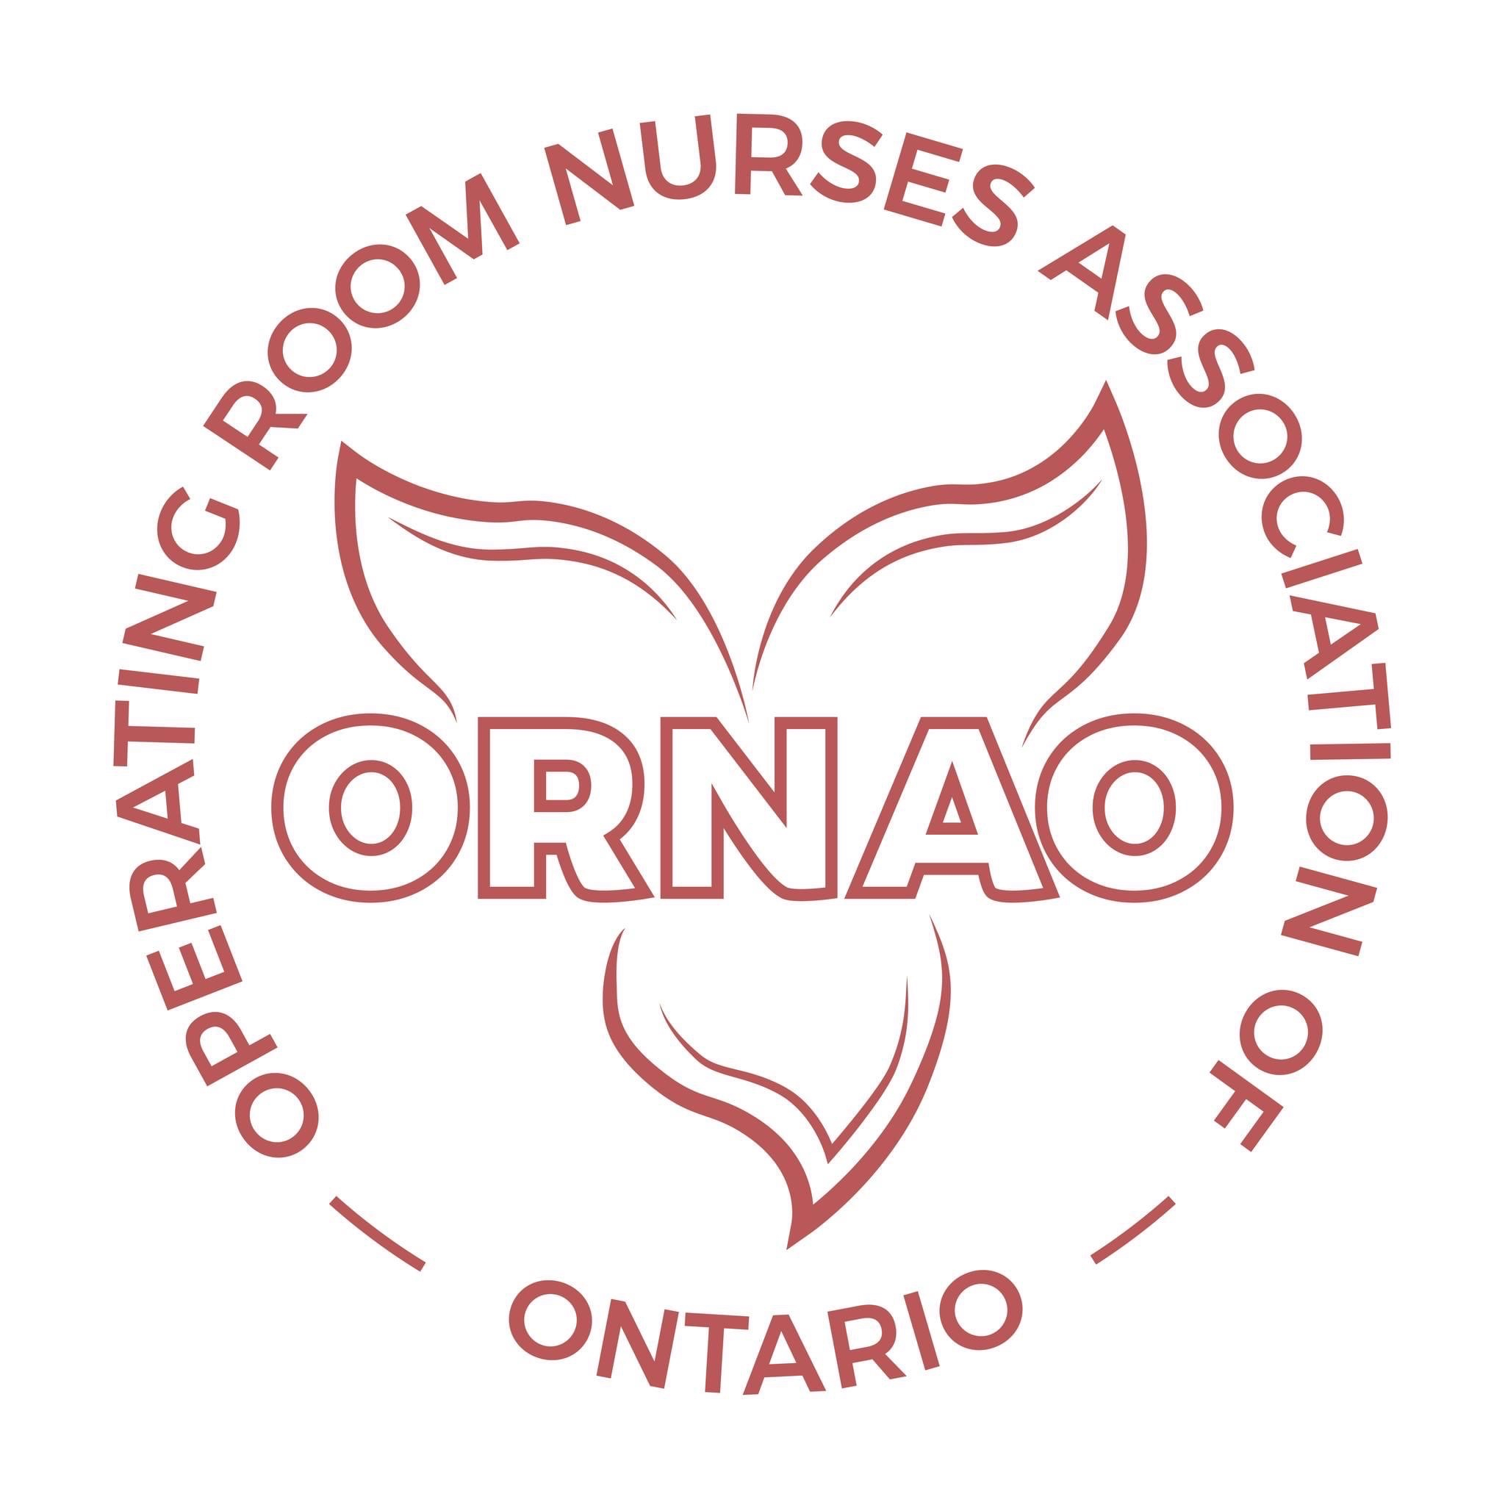
Call for Nominations
Open Leadership Positions for 2023
The Operating Room Nurses Association of Ontario (ORNAO) has the following elected Regional Representative positions open:
- LORNA ( LAKEHEAD OPERATING ROOM NURSES ASSOCIATION)
- L&DORNA ( LONDON & DISTRICT OPERATING ROOM NURSES ASSOCIATION)
- NOORNA ( NORTHERN ONTARIO periOPERATIVE REGISTERED NURSES ASSOCIATION)
- ORNAHD ( OPERATING ROOM NURSES ASSOCIATION OF HAMILTON & DISTRICT)
- ORNASCO ( OPERATING ROOM NURSES ASSOCIATION OF SOUTH CENTRAL ONTARIO)
- ORNGT (OPERATING ROOM NURSES OF GREATER TORONTO)
- ORORNA ( OTTAWA REGIONAL periOPERATIVE REGISTERED NURSES ASSOCIATION)
- SCORNA ( SUNSET COUNTRY OPERATING ROOM NURSES ASSOCIATION)
- SENORA ( SOUTH EASTERN NURSES OPERATING ROOM ASSOCIATION)
- WDPONA (WINDSOR & DISTRICT periOPERATIVE NURSES ASSOCIATION)
Term: 2 years, commencing June 6, 2023 with opportunity to run for an additional 2 year term.
The following ORNAO Executive positions are open:
- President-Elect
- Treasurer
- Secretary

Term: 2 years with opportunity to run for an additional 2 years.
Nominations Deadline: May 1, 2023
Qualifications:
i) Must be a member of ORNAC/ORNAO
ii) Must be a Perioperative Registered Nurse who is working in the perioperative setting
iii) Not an employee or representative of a company whose primary business involves the development, manufacture and sole distribution of products in the field operating room care
iv) The individual cannot be a consultant of ORNAO.

Nominations for these Board positions will be accepted by the Nominations Chair, via the following e mail: nominations@ornao.ca .The nominations application paperwork is available on the ORNAO website at ornao.org.

