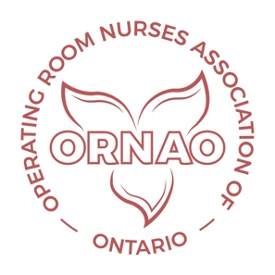
ORNAO Webinar Program for 2024

In order to support the continuing education needs of ORNAO members, and to keep members up-to-date, ORNAO is continuing their webinar series for 2024.

Cost to Sponsor Each Webinar: $2,000.00
- Includes setting up a flyer and promoting the webinar through the ORNAO website and social media
- Registration is set up and monitored for the event
- Access to operating room nurses
- Hosting of the webinar on a Zoom Platform
- Follow up of the webinar by sending a certificate of attendance
- Posting of the webinar recording in the webinar library on the ORNAO website for just in time viewing
Payments will be invoiced and can be made through electronic transfer. The electronic transfer information will be found at the bottom of the invoice.

The following table shows the availability for webinars that will be scheduled on a first come first serve basis.

2024 Webinar Schedule
Month | Dates | Webinar Topic | Sponsor
March | March 19, 2024
May | May 21, 2024 | Cataracts | Alcon  Thornton, Trish Trish.Thornton@alcon.com
September | September 17, 2024 | Reserved | Molinyke  Maria Lopez Maria.Lopez@molnlycke.com
October | October 15, 2024 | Reserved | Steris  Pamudjihardjo, Eva Eva_Pamudjihardjo@steris.com
November | November 19, 2024 | Reserved | Solventum/ 3M  Jackie Efthymiou  E: jefthymiou@solventum.com

Please note that there will be no webinars offered during the months of June, July or August due to member availability.

In order to book a webinar, please e–mail the ORNAO President at: deniseamclaughlin@icloud.com

ORNAO Executive

