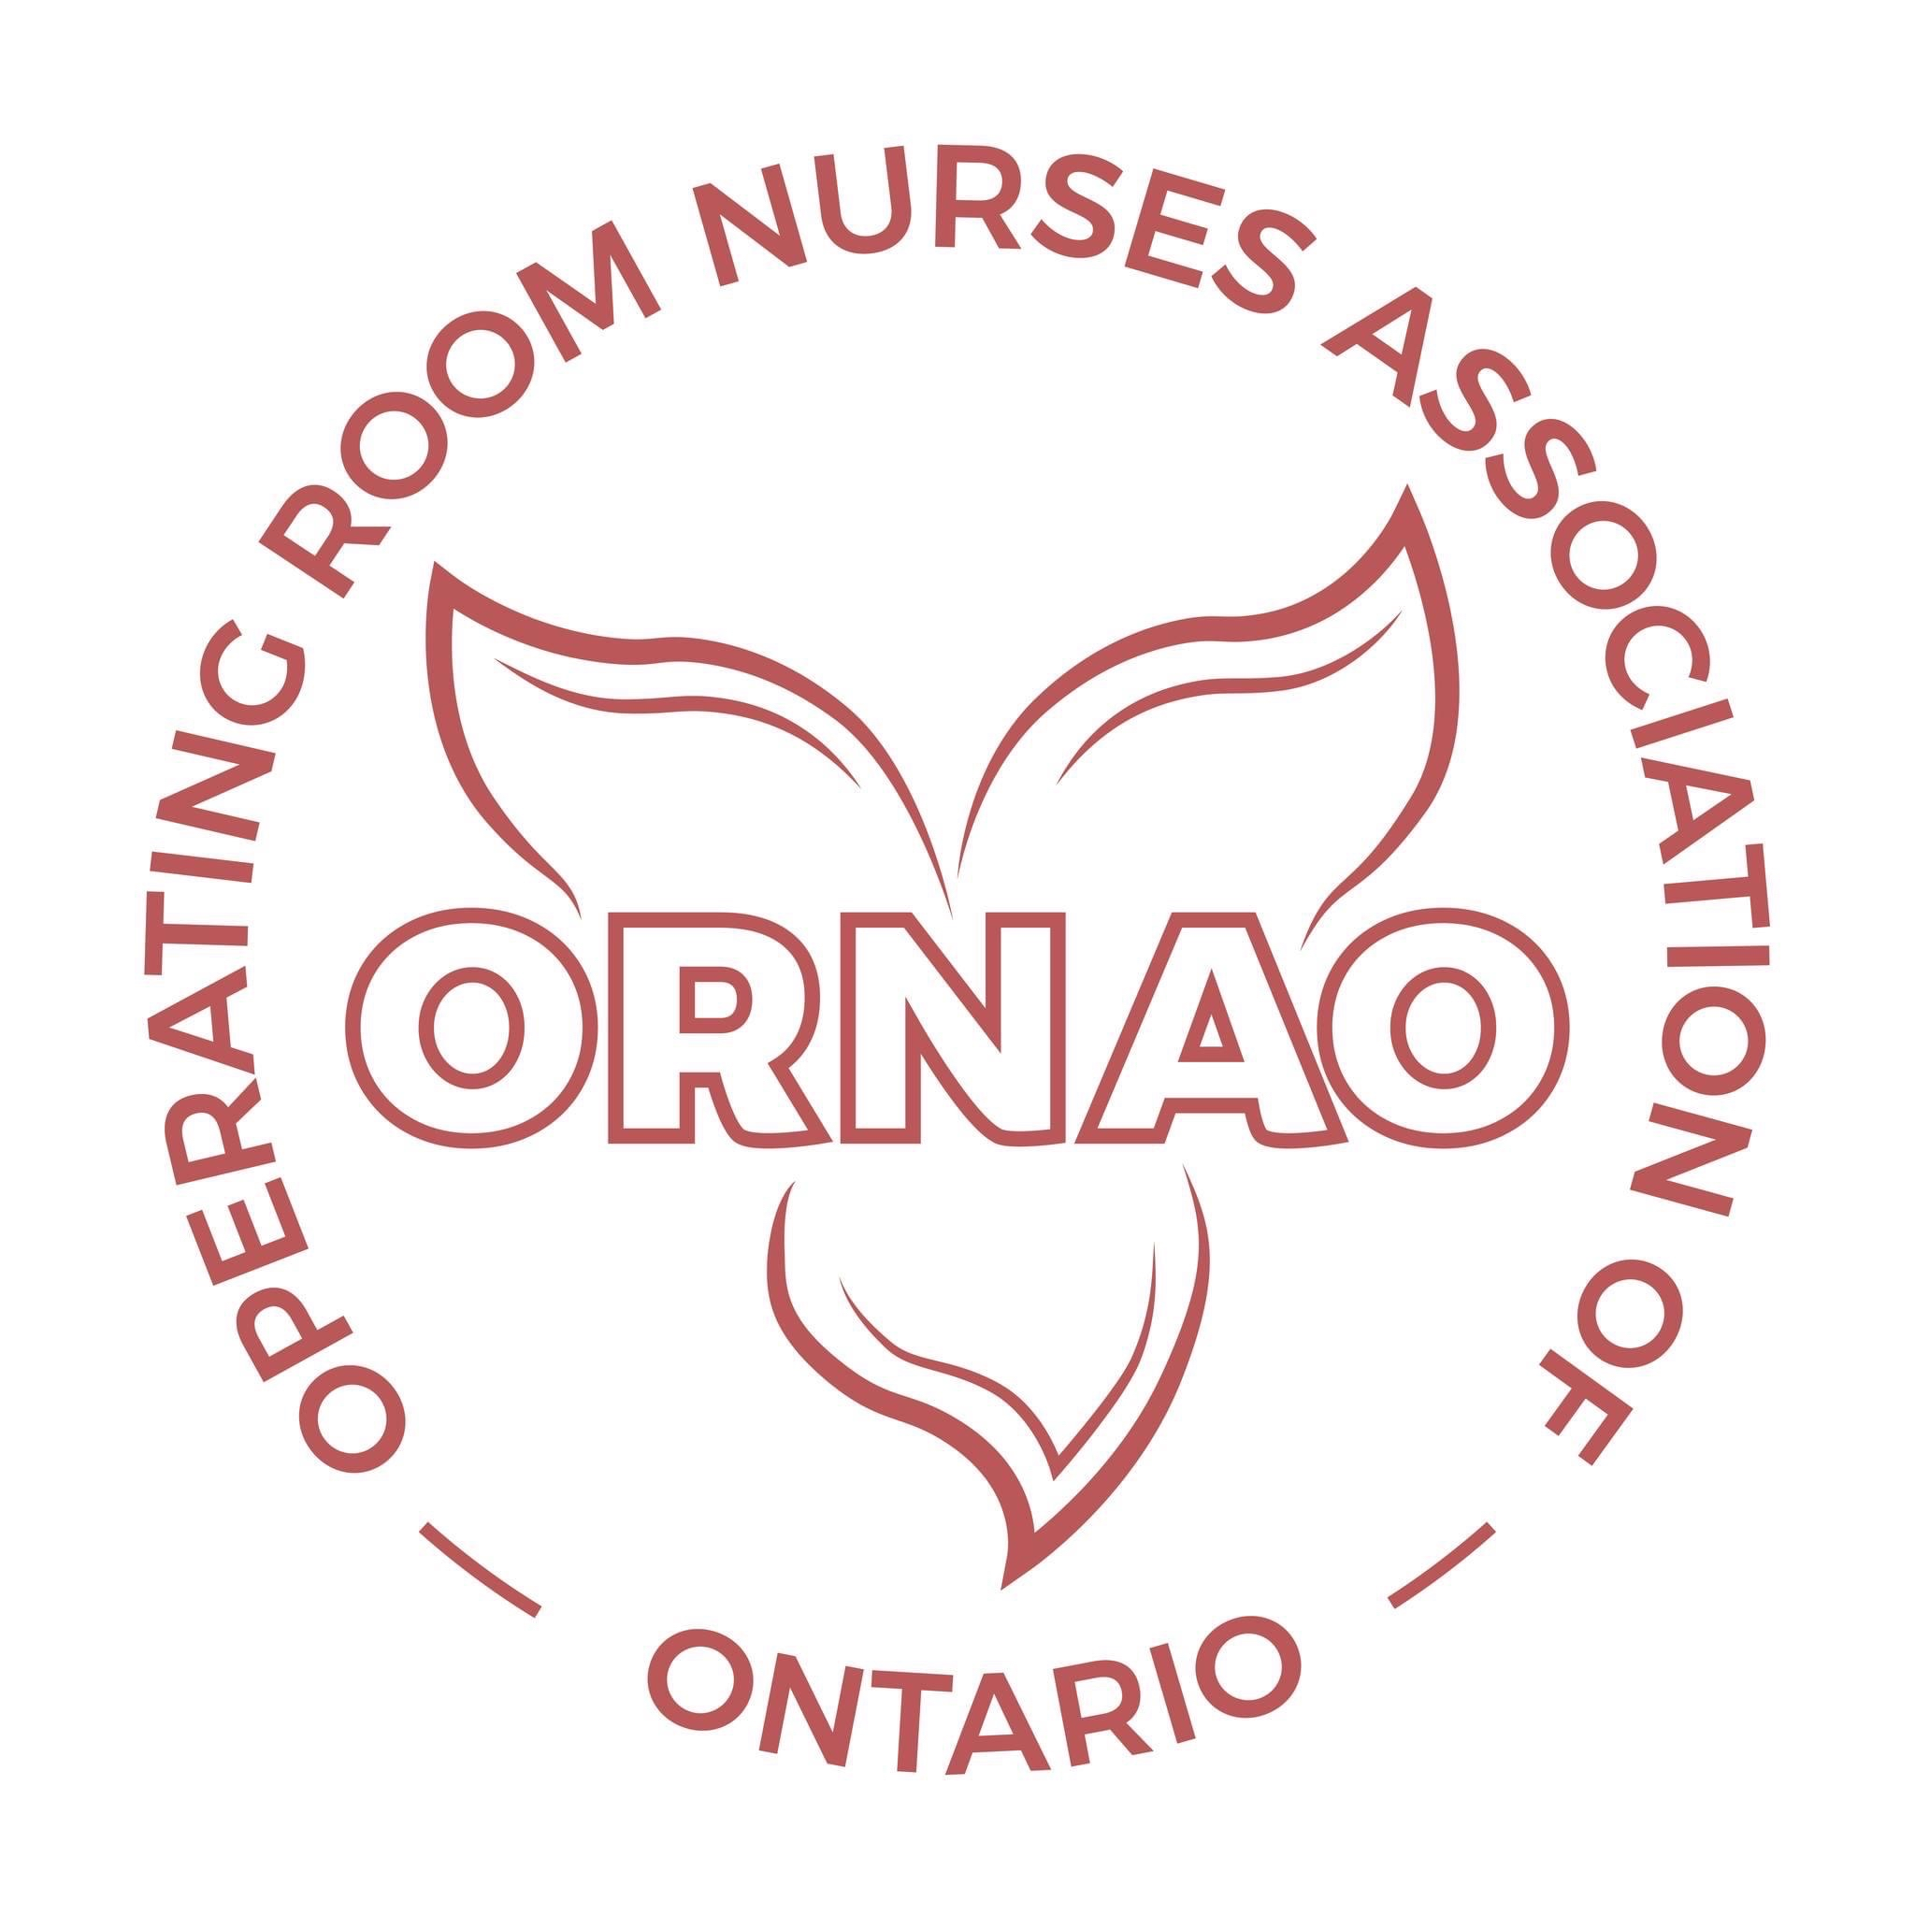

Role Description: ORNAO Regional Representatives
The ORNAO Regional Representatives represent one of the following ORNAO Regions and have the right to one vote as a Board member:
- LORNA ( LAKEHEAD OPERATING ROOM NURSES ASSOCIATION)
- L&DORNA ( LONDON & DISTRICT OPERATING ROOM)
- NOORNA ( NORTHERN ONTARIO periOPERATIVE REGISTERED NURSES ASSOCIATION)
- ORNAHD ( OPERATING ROOM NURSES ASSOCIATION OF HAMILTON & DISTRICT)
- ORNASCO ( OPERATING ROOM NURSES ASSOCIATION OF SOUTH CENTRAL ONTARIO)
- ORNGT (OPERATING ROOM NURSES OF GREATER TORONTO)
- ORORNA ( OTTAWA REGIONAL periOPERATIVE REGISTERED NURSES ASSOCIATION)
- SCORNA ( SUNSET COUNTRY OPERATING ROOM NURSES ASSOCIATION)
- SENORA ( SOUTH EASTERN NURSES OPERATING ROOM ASSOCIATION)
- WDPONA (WINDSOR & DISTRICT PERIOPERATIVE NURSES ASSOCIATION)
Accountability
As a Regional representative and key Volunteer of the association, the Regional Representative provides oversight over the business operations working closely with other members of the ORNAO to support the sustainability of ORNAO.
Authority
The Regional Representative is entitled to make motions and has one vote on matters before ORNAO.
Time Commitment
Three hours month (Board meetings, webinars, dissemination of information to the region as requested by the President)
Term of Office
Two year term with a two year renewal option but must be nominated and elected for the second term.

Responsibilities

1. Communication Conduit between ORNAO and the Region
Liaise with regional membership to share information from ORNAO in order to keep members updated and attract and retain members. The Regional Representative will be provided with Zoom access in order to set up and hold meetings with their regional Members.

2. Organization strategic planning and monitoring
Regional Representatives will be involved in reviewing and implementing the Mission and Purpose statements that articulates ORNAO’s goals and people served. Regional Representative must actively participate in an overall strategic planning process and monitoring of the plan’s goals. As part of this, they may also monitor the organizations’ programs and services to determine which are consistent with the ORNAO Mission and monitor their effectiveness.

3. Protect assets and provide financial oversight
Regional Representatives need to ensure that they’re protecting ORNAO’s assets and managing them responsibly, including carrying out its fiduciary responsibilities. For example, a board should work with the Treasurer to establish a budget, ensure proper controls are in place for incoming and outgoing funds and review the organization’s financial statements. This may also include establishing a Financial Performance Metric and completing a financial review every year.
The Regional Representatives will have access to the ORNAO Treasurer in order to discuss and access the money available to members as per the ORNAO Policy that describes funds that go back to their region.

4. Opportunity to Serve on AD HOC Committees
Regional Representatives have the opportunity to serve on AD HOC Committees and offer to take on special assignments, as this is where the bulk of board work gets done. Boards can also create ad hoc committees or working groups to accomplish specific goals or tasks.

5. Regional Representatives recruitment and board performance evaluation
The Regional Representatives are responsible in participating in the recruitment, nomination and appointments of new Board Executive and Regional Representatives with the right mix of skills, knowledge and experience. Most boards assess their performance on an annual basis to identify gaps and form a strategic plan. An important topic for today’s boards is to address diversity and inclusion in their board recruitment and selection.

6. Active Participation at monthly Board Meetings and annual AGM
Regional Representatives are expected to attend monthly Board meetings in order to contribute to the discussion and decision making process.
Qualifications
- Must be a Member of ORNAC/ORNAO
- A commitment to, and a clear understanding of the Mission of the organization
- Knowledge of meeting procedures, governance policies and by-laws of the Association
- Experience in program planning and strategic planning is an asset
- Sufficient time to devote to their primary duties
- Strong organizational skills
- Strong communication skills
- Reside within their area of regional representation
Development & Evaluation
The Regional Representative shall regularly consult the Executive Board on their expectations of the Regional Representative role and assess his/her strengths and areas for improved effectiveness.
Revised: March 8, 2023.

