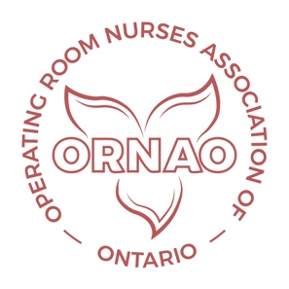
ORNAO Webinar Program for 2025

In order to support the continuing education needs of ORNAO members, and to keep members up-to-date, ORNAO is continuing their webinar series for 2025.

Cost to Sponsor Each Webinar: $2,000.00
- Includes setting up a flyer and promoting the webinar through the ORNAO website and social media
- Registration is set up and monitored for the event
- Access to operating room nurses
- Hosting of the webinar on a Zoom Platform
- Follow up of the webinar by sending a certificate of attendance
- Posting of the webinar recording in the webinar library on the ORNAO website for just in time viewing
Payments will be invoiced and can be made through electronic transfer. The electronic transfer information will be found at the bottom of the invoice.

The following table shows the availability for webinars that will be scheduled on a first come first serve basis.

2025 Webinar Schedule
Month | Dates | Webinar Topic | Sponsor
January | Jan. 21, 2025
February | Feb. 18, 2025
March | March 18, 2025
April | April 15, 2025
May | May 20, 2025
June?
September | Sept. 16, 2025
October | Oct., 21, 2025
November | Nov., 18, 2025

Please note that there will be no webinars offered during the months of June, July or August due to member availability.

In order to book a webinar, please e–mail the ORNAO President at: deniseamclaughlin@icloud.com

ORNAO Executive

