Welcome to ORNAO Website!
WE CELBRATE National Nursing Week across Canada this week, May 6–12, ORNAO
Would like to reflect on the valuable contributions nurses make every day and in so many ways.
Nurses are the face of health care, contributing to life saving treatments for the communities we serve. Each of us embody leadership, mentorship and continuously demonstrate our commitments to lifelong learning, patient safety and advocacy in delivering best practices.
Nurses are the heart of health care.
Let’s recognize, the contributions of ALL nurses across Ontario, and beyond. Our nursing profession, dedication, compassion and competencies impact those we care for like no other profession. Thank you for the difference you make for patients, students, colleagues and your community, wherever you are.
Nurses are the future of health care.
On behalf of the ORNAO, I humbly express graduate and appreciation for your pledge for patient safety, supporting one another and shaping the future.
This week is about you! Take some time to celebrate one another, reflect on your achievements and value you bring to patients and the health care team, every day!

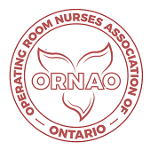 | Denise McLaughlin RN, BScN, CPN (C)  ORNAO President

